Lab 1: First ASP.NET Core Web API
Objective
To create a simple ASP.NET Core Web API, understand RESTful services, HTTP verbs, and execute the default GET endpoint using Swagger.
Commands Used
dotnet new webapi -n FirstWebAPI
cd FirstWebAPI
dotnet run
Code
Program.cs
var builder = WebApplication.CreateBuilder(args);
// Add services to the container.
builder.Services.AddEndpointsApiExplorer();
builder.Services.AddSwaggerGen();
var app = builder.Build();
// Configure the HTTP request pipeline.
if (app.Environment.IsDevelopment())
{
app.UseSwagger();
app.UseSwaggerUI();
}
app.UseHttpsRedirection();
var summaries = new[]
{
"Freezing", "Bracing", "Chilly", "Cool", "Mild",
"Warm", "Balmy", "Hot", "Sweltering", "Scorching"
};
app.MapGet("/weatherforecast", () =>
{
var forecast = Enumerable.Range(1, 5).Select(index =>
new WeatherForecast
(
DateOnly.FromDateTime(DateTime.Now.AddDays(index)),
Random.Shared.Next(-20, 55),
summaries[Random.Shared.Next(summaries.Length)]
))
.ToArray();
return forecast;
})
.WithName("GetWeatherForecast")
.WithOpenApi();
app.Run();
record WeatherForecast(DateOnly Date, int TemperatureC, string? Summary)
{
public int TemperatureF => 32 + (int)(TemperatureC / 0.5556);
}
Output
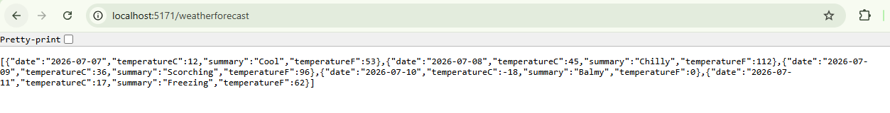
Result
A simple ASP.NET Core Web API was successfully created and executed. The application responded to the GET request at /weatherforecast and returned JSON data, demonstrating the basic working of a RESTful Web API.

